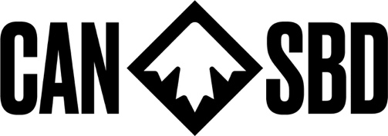
ACCEPTANCE OF SUPERVISION & RESPONSIBILITY BY A NON-CANADA SNOWBOARD COACH REPRESENTING AN ATHLETE

I agree that I will function as a Coach to and will be responsible for imparting all necessary information to, including all information related to safety, weather, course conditions and information provided by LOC for athletes, and I will provide advice and coaching information regarding the following training and competition events as well as any training associated with these events for the athlete named below:
NAME OF ATHLETE:
FIS CODE:
CALENDARED EVENT(s):
DATE(S) OF TRAINING DAYS & COMPETITION:
LOCATION OF COMPETITION
I HAVE READ THIS ACCEPTANCE OF LIABILITY CAREFULLY, AND HAVING DONE SO, I AM SIGNING IT VOLUNTARILY.

PRINTED NAME:
SIGNATURE:
NSA AFFILIATION:
DATE:

